Green Impact is launching for the 2018/19 academic year and we’d love for you to be involved!
A simple guide for new Green Impact teams

What is Green Impact?
Green Impact is a simple and effective way for people to make positive changes to the workplace and our environment, improve their health and wellbeing, connect with other staff across the University and provide students with excellent opportunities.

How does Green Impact work?
Staff take part by doing fun and engaging actions in an online toolkit. The actions are split into different categories, such as bronze, silver and gold. Teams can be made up of a department, college, building, lab or even a floor of a building – whatever suits you. You can register now and then start recruiting members before getting going with the toolkit. You’ll receive support at every step of the process and could win an award later in the year.

Will Green Impact be a lot of work?
No. On average you can spend as little as a few hours a month doing it. Different teams find different ways of completing Green Impact, depending on the award level they choose to go for and the number of people in their team. Before we allocate awards you’ll have at least six months to complete the actions and there will be lots of support available. If it’s too much, you can do just a few actions this year and receive a “working towards Bronze” certificate.

Why should I get involved?
Green Impact is easy, free, fun and rewarding. By participating you’ll get to:
- make the university a more enjoyable and efficient place to work;
- work with new people from both within and outside of the university;
- learn about social, health and environmental issues and make a real impact;
- be recognised for positive actions you’re doing already;
- attend (and maybe win something at!) the annual awards event.

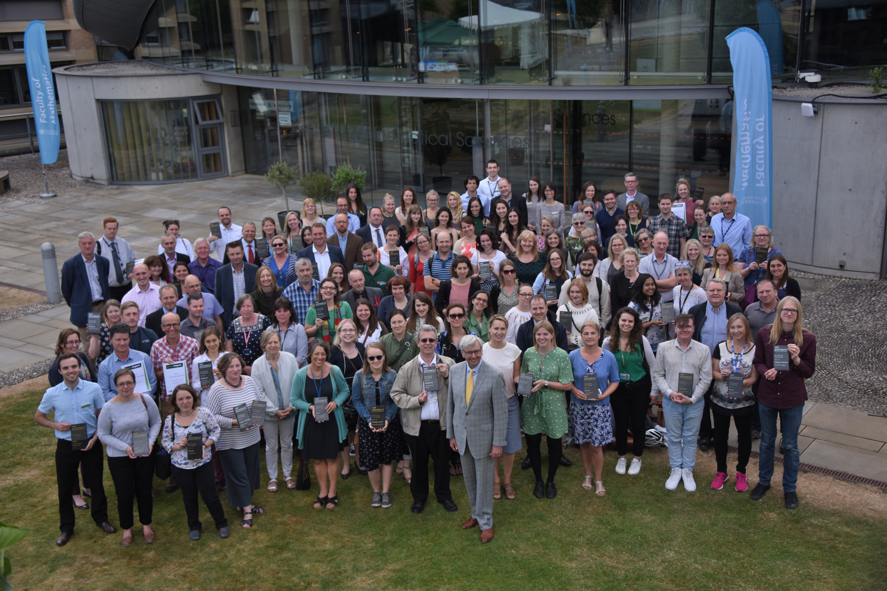
How will I be supported?
You’ll receive regular communications (but we promise not to spam you!) and there will be support events throughout the year. Of course, we’re at the end of the phone and email if you need us – contact details are below. You can also be buddied with a trained student volunteer (a Green Impact Project Assistant) to help add capacity to your team and provide them with a development and learning opportunity.

What awards can be won?
Working Towards Bronze - Start doing any of the actions even if it's only a few;
Bronze - Complete all the Bronze actions;
Silver - Complete all Bronze and Silver actions;
Gold - Complete all Bronze and Silver actions and 130 points from the Gold actions.
There are actions specifically designed for colleges and laboratories, plus special awards handed out at the end of the year for innovative ideas and committed people.

How do I get involved?
Simply register your team name and contact details at: www.greenimpact.org.uk/cambridge

For further support
- Have a look at the helpful video guide on the Green Impact workbook homepage.
- Keep an eye on the Greenlines newsletter, (www.environment.admin.cam.ac.uk/greenlines)for details of support workshops and more.
- Email greenimpact@admin.cam.ac.uk or call 01223 337786 with any questions.

