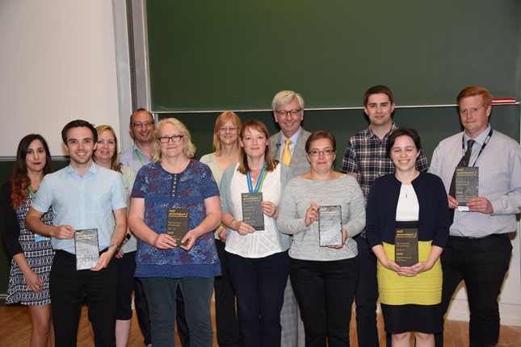
Green Impact is back for 2018/19!
A guide to what’s changed - for existing Green Impact teams

What’s changed this year?
- A number of minor edits to wording of criteria have been made throughout the workbook.
- There is now one less criteria in Bronze – B017 has been moved to S015.
- A Silver action (S007) has been moved to Gold (G033), and replaced with G025. G025 is replaced by a new criteria focus on staff training.
- Gold G012 has been removed and replaced by a new criteria focused on Building User Guides.
- Gold G063 & G073 are new criteria focused on waste & recycling.
- There are several new College criteria – CT044, CT089, and CT090.
- The Labs tab has been overhauled to simplify and streamline this part of the workbook. This includes the removal of 6 previous criteria (L005, L007, L010, L013, L015, L065). Changes in wording have been made to criteria including L005, L009, L012, L013, L014, L015, L018, L025, L037, L045, L053, L056, L066 and L073. As a result of this change the scoring threshold have also been altered slightly – see the workbook intro page for details.
- Note: Wherever new criteria have been added into the workbook or old criteria have been deleted, this may have changed criteria numbers. Bear this in mind when migrating actions from the previous year (see guidance below)
Workbook reminders and tips
Migrating previous years’ evidence - If your team took part in previous years, you can transfer evidence and actions from previous years’ workbooks to this year’s. For full details see the workbook guide at www.environment.admin.cam.ac.uk/guidance
Printing the workbook – Remember that there is a printer symbol in the top right hand corner on each of the criteria pages. This lists the criteria in a print-friendly format, although of course we recommend you only print if absolutely necessary! There’s also an option to download an excel copy of the workbook.
Changing the membership of your team - Any new members of your team need to register themselves. To remove any members of your team who are no longer involved, email greenimpact@admin.cam.ac.uk with their details.

What are the options for Gold-winning teams?
There are two options for Gold-winning teams who want to go even further:
- Go for Platinum. Platinum is similar to Gold and works in the same way, but requires a new and challenging points total to be met! This is good for teams who want to do more, but are keen to follow the structure provided by the Gold tab.
- Go for Excellence. Now in its third year, Excellence projects are a way for your team to take a break from the ‘normal’ workbook and focus on one bigger project. For a briefing document on Excellence, visit:
www.environment.admin.cam.ac.uk/guidance

Excellence support
For those teams opting to carry out an Excellence project, visit the link below for the four documents needed at each stage of the year:
www.environment.admin.cam.ac.uk/guidance
This year’s event calendar
- Spotlight on Waste month – November
- Spotlight on Energy Month – February
- Spotlight on Biodiversity Month – April
What support is available?
- In October, training was carried out for Green Impact Project Assistants. These are students trained in leading or assisting Green Impact teams in completing the workbook. If you need some extra support this year, why not get in touch?
- Keep an eye on the Greenlines newsletter, or the bi-weekly digest (sent to your Environment & Energy Coordinator) for details of events, ideas and more.
- Email greenimpact@admin.cam.ac.uk or call 01223 337786 with any questions.
Going for Silver or Gold? Here’s a quick guide to which Bronze actions need refreshing:
- B001 –This criteria ideally needs refreshing with a more recent set of minutes.
- B002 – This doesn’t need refreshing, although be aware that auditors may ask to speak to new members of staff.
- B003 – Send the Environment & Energy section 2 photos from this year
- B004 – Upload some evidence of communication this year (Note Gold G008 could fulfil this criteria)
- B005 – Upload evidence of involvement (although note that Silver criteria S004 S007 or Gold criteria G032 G052 or G064 could fulfil this requirement)
- B006 – This criteria states ‘within the last 12 months’ so should be completed. Note however that implementing one of the ideas is not required within the last 12 months.
- B007 – This criteria should be completed again. See http://www.environment.admin.cam.ac.uk/top-tips for inspiration!
- B008 – This criteria states ‘within the last 12 months’ however this criteria only needs updating if new units have been installed.
- B009 – No update required assuming stickers and posters are still in place. (It is best practice however to replace these on a reasonably regular basis.)
- B010 – No update required assuming no change to light switches.
- B011 – No update required assuming policy still actively practiced.
- B012 – Update required, however this could link to Silver S013 or Gold G052
- B013 – Update required, however this could link to Silver S013 or Gold G052
- B014 – No update required assuming system still in place
- B015 – No update required assuming system still in place
- B016 – No update required assuming system still in place (however note that a new set of posters was introduced in August 2016)
- B017* – Update required, however this criteria could link to completing G064 and/or G065
- B018* – No update required assuming no change to settings.
- B019* – No update required assuming ongoing awareness
Going for Gold? Here’s a quick guide to which Silver actions need refreshing:
- S001 – No update required assuming no change to EEC
- S002 – No update required as this criteria is not time-limited, however we would encourage continual engagement with students
- S003 – No update required assuming no change to senior management involvement
- S004 – Update required, however note that Gold criteria G032 G052 or G064 could fulfil this requirement.
- S005 – Needs updating, however note that this could be an update to the audit OR implementation of an action.
- S006 – No update required assuming no change to heater use.
- S007* – No update required
- S008 – No update required assuming practice still active
- S009 – No update required, however best practice would be to review whether any new equipment is in place.
- S010 – No update strictly required, although it is recommended that regular checks are carried out/staff updated.
- S011 – No update required assuming no change to policy.
- S012 – Update required
- S013 – No update required assuming practice is ongoing
- S014 – No update required assuming target met.
- S015* – Update required, if applicable
- S016* – No update required assuming labels still in place.
- S017* – No update required, assuming no change to water provision.
*Note change to criteria number/content from last year’s workbook

