Spotlight On Biodiversity Month – April 2019
This April, for Spotlight on Biodiversity month, we’re encouraging you to get out and explore your local environment.
Biodiversity is the “wealth of wildlife” – the number and abundance of species - incorporating both rare and common species and habitats; all of which play a vital role in ecosystems. A healthy ecosystem can provide a variety of ecosystem services such as soil formation, nutrient recycling, climate regulation, flood control and social benefits such as education, recreation and tourism. Biodiversity also has an intrinsic value which we have a responsibility to protect for future generations.
Biodiversity in Cambridge
Within Cambridge we’re lucky to have access to a number of Local Nature Reserves.
The University also plays a part in local biodiversity what with it owning approximately 65ha of woodland, including Madingley Wood - a site of special scientific interest.
As a University, we are committed to limiting negative and, where possible, having positive direct and indirect impacts on biodiversity and natural ecosystems.

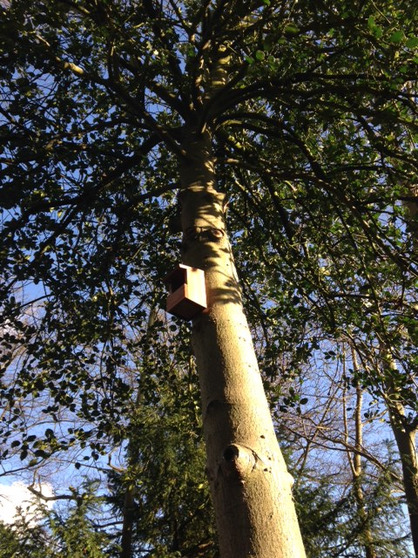
Things you could do in your department/ College
Organise or attend a lunchtime nature walk – identifying plants and animals around them on a lunchtime. Get people to download the iRecord app to record data, help with identification and get involved in citizen science. If you would like to brush up on your wildlife knowledge before your walk, you can use these image guides.
Put up bird and bat boxes, wood piles, community planters and wildflower meadows.
Grow your own using community planters (see Maths case study below) or College gardens.
Increase the biodiversity inside your department using plant pots and even hydroponics (see Engineering case study below).
Organise a themed event or day, such as an ‘Ecosystems Day’, to focus your events and engagement efforts. A day like this could include nature walks for staff for example.
Raise awareness of the health benefits connected to nature and getting out into the open.
Organise a talk or panel discussion from conservationists or biodiversity experts. There are plenty to choose from, as Cambridge is a major hub for conservation work, including the Cambridge Conservation Initiative (CCI).
Case study: Centre for Mathematical Science (CMS)
CMS built a community planter outside their reception area, where they planted all sorts of delicious plants and herbs including tomatoes, basil, and mint.
CMS have also put up about a dozen bird boxes around their campus, celebrate lush lavender beds next to their buildings and are planning a wildflower meadow on their green roof.
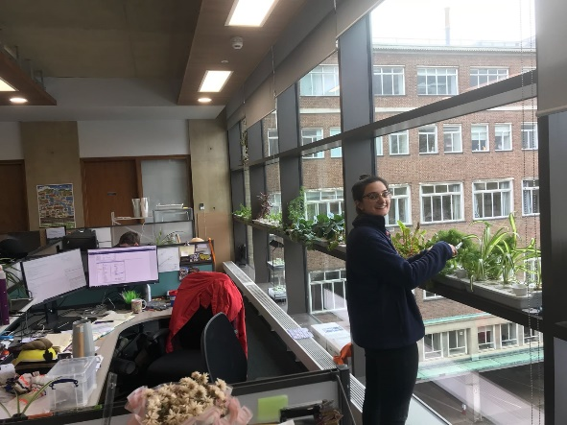
Case study: Hydroponics in the Engineering Department
Students in the Engineering Department ran a hydroponics scheme designed to decrease carbon dioxide and temperature in offices.

Get involved with
Citizen science projects such as:
- ispot: When you’re outside, you can use this app to record observations of biodiversity, share with fellow naturalists and help with identification.

- #POKEBLITZ: If you’re outside playing Pokémon Go and see an animal (or even a plant), take a picture! If you don’t know what the animal/plant is, make sure to tweet it out, tagging it with the hashtag #PokeBlitz. Try to include location information and where you saw it. Actual scientists will help you identify what it is!
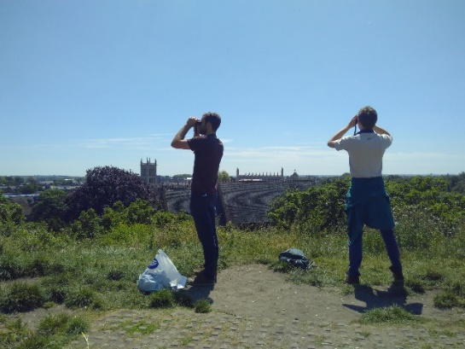
- Swift survey in June for Action for Swifts (see right).

- The Big Butterfly Count in July and August by simply counting the number of butterflies for 15 minutes during bright (preferably sunny) weather and submit your findings online at www.bigbutterflycount.org or by using the free apps available for iOS and Android.
Swift survey for Action for Swifts in June 2018.
Other things to get involved with:
- ‘Random acts of wildness’: doing ‘random acts of wildness’ to celebrate nature, just as The Wildlife Trust did in June 2018. Their top five ideas for random acts of wildness:
- Visit your local nature reserve
- Listen to the dawn chorus
- Climb a tree
- Keep a record of garden wildlife
- Watch the sunrise or sunset

- ‘Scudamore’s punting bat safaris’ where they punt for adventures at dusk towards Grantchester Meadows for a chance to see local bat populations. Bookings here.

- Cambridge Zoology Museum events.

- Visit the Cambridge University Botanic Gardens and look out for their events.

- Wildlife gardening at home - some tips here.

- The Wildlife Trust events.

- The Cambridgeshire Bat Group events who organise bat walks, workshops, Bioblitz’s, trapping, etc.
- A free guided tour of the Local Nature Reserves in and around Cambridge.

