Energy monitoring project results
  - July to September 2017

Description of the paper
This paper provides the results of an energy monitoring project at a medical research labs building at the University of Edinburgh.

Methodology
Four 3-phase electricity monitors were installed in the distribution boards to monitor four electrical distribution boards (DBs) which (roughly) cover the 2nd floor labs, 2nd floor offices, 3rd floor labs and 3rd floor offices (each DB may have a mixture of office and lab space, but will be predominantly one or the other). Energy data was captured from 5th July until 26th September. It had been hoped that we could also monitor how busy each space was through footfall counters, however equipment to monitor this was not available until the end of the project. Instead, data has been used from H.R. files which indicates days of absence (for annual leave or sickness), from which variations in the populations of the 2nd and 3rd floors have been deduced.
After an initial monitoring period to establish a baseline, posters were installed around the site advising of energy saving practices on the 31st July. This was followed up by a further period of monitoring prior to face-to-face presentations on energy saving practices being provided on 22nd and 23rd August. Attendance at the presentations was low, with perhaps a maximum of 20 staff attending in total across both sessions.

Data collection and manipulation
The energy monitors needed to be extracted at regular intervals in order to recharge batteries for several hours (overnight). As such days at the beginning or end of a monitoring period have only partial energy recording as either the evening or morning is missing. These days have been removed from the energy data presented below, in order that only full 24h periods can be shown and compared. The first and second monitoring periods ended in an uncontrolled manner when batteries ran out. As such, the period of time covered by the first and second monitoring periods varies depending on the battery life of the individual monitor. The 3rd floor lab monitor also has missing data from 1st August until 10th August (for some reason the period of monitoring from 4th August to 9th August which other monitors successfully captured seems not to have worked on this monitor).
For the 2nd and 3rd floor labs the first two monitoring periods were July 5th to July 17th, and July 21st to August 1st.
For the 2nd floor offices the periods were: July 5th to July 16th , and July 21st to August 2nd.
For the 3rd floor offices the periods were: July 5th to July 14th , and July 21st to August 2nd.
This required the removal of energy data from the following dates:
July 5th, (14th, 16th, 17th ) and 21st.
August (1st, 2nd) 4th, 9th, 10th, 17th, 18th, 23rd, 24th and 31st
September 1st, 7th, 8th, 14th, 15th and 26th.
(dates in brackets denote dates which are included in some datasets but not others, depending on when the battery ran out)

Energy consumption results
The below graphs exclude dates with partial data. Weekend dates have been included.

2nd floor lab
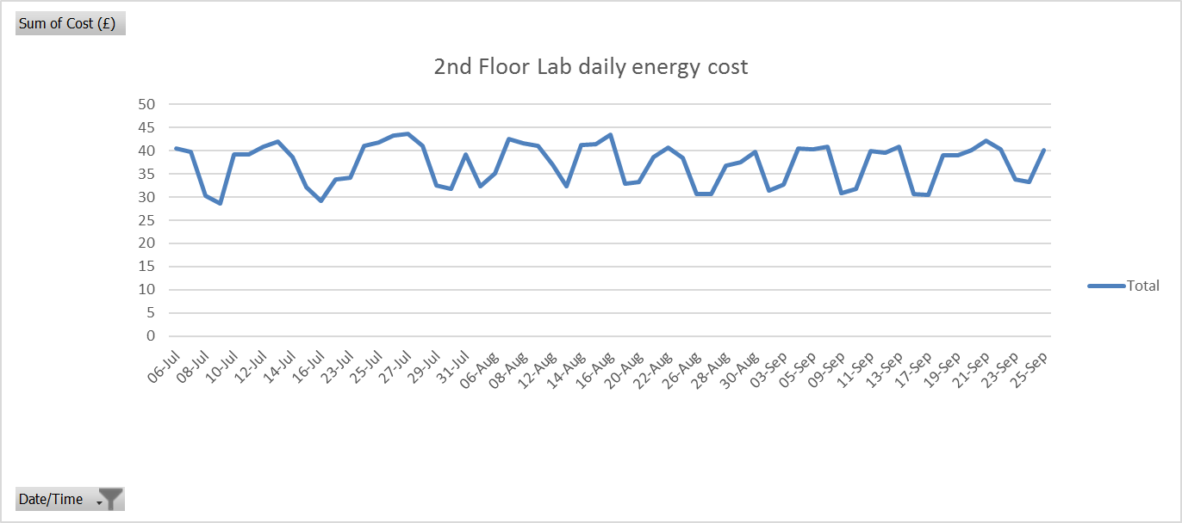
The 2nd floor lab monitoring shows no discernible reduction in energy consumption. In fact, the trend seems to have been towards increasing energy consumption, mainly via slightly increased weekend consumption.
The average daily energy cost of the first 15 days was £36.77, the average of the last 15 days was £36.81, an increase of 0.1%.

3rd floor lab

The 3rd floor lab energy cost monitoring shows a slight decrease over the monitoring period. Slightly lower week-day peaks can be observed, especially around the period at the end of August, beginning of September. This coincides with the energy saving presentations from SRS on 22nd and 23rd August, but other factors could also be at play. Regardless, week-day peaks rose in mid-September, although remaining slightly lower than in July.
The average daily energy cost of the first 15 days was £24.48, the average of the last 15 days was £22.18, a decrease of 5.5%.

2nd floor offices

The trend of this data shows that week-day peaks declined throughout the period until the week of 13th September when they began to rise again to the highest recorded peak on 29th September of almost £30/day. However, weekend use remained low during this period, when compared with the beginning of the monitoring period.
The average daily energy cost of the first 15 days was £24.56, the average of the last 15 days was £23.45, a decrease of 4.5%.

3rd floor offices

The most noticeable feature of the energy data in the 3rd floor offices is the small difference between weekday and weekend use. This may be due to efficient consumption during the weekdays, or inefficient consumption during weekends. In comparison with the 2nd floor offices the weekend troughs seem quite high in the 3rd floor offices, indicating comparatively higher energy consumption over weekends. When we take into account that weekday consumption is lower at the 3rd floor offices (compared with 2nd floor offices) it is even more striking that the weekend energy consumption is higher in this space.
Another obvious trend is that both weekend and weekday consumption increase from around 17th September after a period of relative stability throughout August.
The average daily energy cost of the first 15 days was £22.32, the average of the last 15 days was £24.04, an increase of 7.7%.

Energy consumption per person results

2nd floor Labs

The energy cost per person in the 2nd floor labs shows an overall downward trend over the period, with a fairly noticeable change in late August when the peaks become substantially lower (troughs remaining around the same level).
The average daily energy cost per person of the first 15 days was £0.84, the average of the last 15 days was £0.70, a decrease of 16%.

3rd floor labs

The energy cost per person in the 3nd floor labs shows an overall downward trend over the period, with a relatively subtle change in late August when both the peaks and troughs become lower.
The average daily energy cost per person of the first 15 days was £0.62, the average of the last 15 days was £0.47, a decrease of 24%.

2nd floor offices

The energy cost per person in the 2nd floor offices shows an overall downward trend over the period, with a noticeable change in late August when both the peaks and troughs become lower.
The average daily energy cost per person of the first 15 days was £0.56, the average of the last 15 days was £0.45, a decrease of 20%.

3rd floor offices

The energy cost per person in the 3rd floor offices shows an overall slight downward trend over the period, with the lowest readings in early September but a rising trend in mid-late September.
The average daily energy cost per person of the first 15 days was £0.58, the average of the last 15 days was £0.51, a decrease of 12%.

Combined offices and labs per floor
Combined labs and offices energy cost per person per day on the 2nd floor dropped by 17.9% (£1.40 to £1.15), while on the 3rd floor the drop was 18.4% (£1.20 to £0.98).

Discussion

Medium term impact of engagement
Taking the whole monitoring period into account, the below table summarises the findings when the first 15 days are compared to the last 15 days.
Location | % change in average daily energy cost per person
2nd floor lab | -16%
3rd floor lab | -24%
2nd floor offices | -20%
3rd floor offices | -12%
Data from beginning and end of monitoring period

Short term impact of engagement
The average daily energy cost for the 15 days prior to placement of posters on 31st July, compared with the 15 days after the placement of posters shows the below impact:
Location | % change in average daily energy cost
2nd floor lab | -2%
3rd floor lab | -5%
2nd floor offices | -6%
3rd floor offices | -3%
Data from 15 days before and after placement of posters
The average daily energy cost for the 15 days prior to face to face engagement presentations on 22nd and 23rd August, compared with the 15 days after the presentations shows the below impact:
Location | % change in average daily energy cost
2nd floor lab | -15%
3rd floor lab | -21%
2nd floor offices | -16%
3rd floor offices | -8%
Data from 15 days before and after energy saving practices presentation

Inter-site comparison
The 2nd floor labs are easily identified as the highest energy consumer, with weekdays often over £40/day and weekends almost always over £30/day.
The energy consumption at the other sites is quite comparable.
The 3rd floor lab energy consumption during weekdays is in the high-£20s/day, but drops significantly over weekends to around £15/day.
The offices both have lower weekday peaks, at around mid-£20s/day, but also higher weekend troughs in the high ‘teens of £/day.

Offices vs labs
Given the sometimes 24/7 nature of life-science research it might have been expected that it would be easier to switch off office equipment over weekends and evenings, giving lower troughs for the offices than for the labs. However this seems not to be the case with the 3rd floor lab at least, which achieves lower weekend troughs than the associated 3rd floor offices, and lower costs per person by the end of the monitoring period.

Impact of engagement
Energy consumption when described in relation to the site population (daily energy cost per person) has dropped at all sites by a substantial amount over the monitoring period (ranging from 12 – 24%). The cause of such a reduction in energy consumption per person may be associated with improved efficiency of practices – for example switching off more items of equipment when not in use, especially over nights (weekend consumption seems to have varied less). However, it could also be due to the variations in populations during the monitoring period, with lower populations in all locations at the beginning of the period, and higher at the end. This increase in population will mean that the energy consumed by communal equipment which must remain ‘on’ permanently or for long periods of time will be shared among more individuals, and thus the energy intensity of any one individual is reduced. This could account for some of the reduction in energy cost per person per day.
However, bearing all of the above in mind, it still appears that there was a coincident reduction in energy use at some sites (specifically the labs) which could be attributed to the timing of the face-to-face presentation sessions.

Future recommendations
It is recommended that the same H.R. data be sought and monitoring equipment be returned to the same sites in future, perhaps at end of November (3 months after the presentation) to ascertain whether practices have remained efficient, or if energy consumption per person has returned to higher levels.

Appendix – Phase 2 data gathering December 2017
From 28th November to 10th December 2017 energy monitoring equipment was reinstalled to monitor the 2nd Floor Labs, 3rd Floor Labs and 3rd Floor Offices. In addition HR for the building provided data on staff absences from sickness/annual leave. The aim of this monitoring was to understand if the energy reductions achieved in the summer (noted above) would be long-lasting or not. The data has provided the following results:

 | Average energy cost per person per day
Site | July 2017  (Before Engagement ) | September 2017  (1 month after engagement) | December 2017  (4 months after engagement) | % change June to Sept | % change Sept to Dec | % change June to Dec
2nd Floor Labs | £0.84 | £0.70 | £0.73 | -16% | +4% | -13%
3rd Floor Labs | £0.62 | £0.47 | £0.46 | -24% | -2% | -26%
3rd Floor Offices | £0.58 | £0.51 | £0.53 | -12% | +4% | -9%

This can be interpreted as encouraging news about the longevity (at least in the medium term) of impact of face-to-face energy engagement with staff.
As with data analysis above, the first and last days of the monitoring were excluded from the data set as they were incomplete days and thus were providing skewed outlying exceptionally low results.
Seasonality (summer to winter) may have influenced results slightly through the monitored equipment operating in a hotter room environment in summer versus winter, however the impact of this is thought to be low due to the temperature control exerted upon the rooms by air handling systems. In addition, some of the energy consumption monitored in labs would be from equipment which would have reduced energy consumption in a hotter room environment (e.g. incubators/incubator shakers). Thus, from the data we have available, it is reasonable to assume that the observed energy consumption differences result from behaviour changes among staff.

