Contents
1 Spotlight on Travel month 2
2 Sustainable travel 2
2.1 Why commute sustainably 2
2.2 Why travel sustainably at work? 2
3 Event or promotion ideas - travelling sustainably to work 3
3.1 Taking the bus or the Park and Ride 3
3.2 Carshare 3
3.3 Cycling 4
3.4 Walking 4
3.5 Train travel 5
4 Event or promotion ideas -travelling sustainably at work 5
4.1 Air travel in your department 5
4.2 Utilising pool bikes 5
4.3 Car clubs 6
5 Tell us all about your Spotlight on Travel plans 6
5.1 Newsletters 6
5.2 Social media 6

Spotlight on Travel month

The clocks are about to go back, and the longer days give us a great opportunity to consider our options when it comes to travelling to work and at work. Throughout Spotlight on Travel month in April the Environment and Energy (E&E) section will draw attention to the impact that travel has, and the support that exists to assist staff in their journeys.

It’s not just about us; we would like you to get involved! Why not talk to your colleagues, find out what the travel issues for you and either in conjunction with the E&E team or with your colleagues put together a travel event? There are many engaging things that you can do and this document provides details just a few suggestions.

Sustainable travel

Why commute sustainably?

Travelling to work and at work can have a big impact on your day in terms of the time it takes and how much it costs us, but there are also further impacts for our city, for the environment and for our health.

The University of Cambridge is a major employer in the city of Cambridge and as such, has a sizeable impact on congestion and road traffic within the city. Travelling sustainably reduces the number of cars on the road and helps our city to keep moving. As the city population expands, sustainable travel will only become more important.

From an environmental perspective, each mile we travel in our vehicles produces carbon dioxide emissions (table 1) which contribute to climate change, while carbon monoxide and nitric oxides contribute to air pollution at a local level.

When it comes to health, the NHS estimates that by being more active in our daily travel i.e. walking and cycling more, could avoid healthcare costs of £17 billion and cycling to work has been shown to reduce the risk of cancer and heart disease.

Journey type | Carbon emissions per mile per passenger
Bike | 0 kg CO₂ e
Singly occupied car (small petrol car) | 0.23 kg CO₂ e
Singly occupied car (4x4 diesel) | 0.35 kg CO₂ e
Bus | 0.16 kg CO2 e
Train | 0.07 kg CO2 e
Table 1: A comparison of carbon emissions (Source: DEFRA Carbon conversion factors 2017)

For all of the reasons detailed above, the University has committed to a target of 25% or less of single occupied vehicles travelling to work each day and has provided a number of alternatives for staff, which we will publicise during Spotlight on Travel month.

Why travel sustainably at work?

One of the big focuses of Spotlight on Travel month will be the impact of the travel that we do as part of our work, be it the international flights that staff and students take as part of their research or the trips to meetings and conferences we make within the UK.

Flights in particular have a large environmental impact, with a flight from London to New York and back generating roughly the same amount of carbon dioxide emissions as the average European householder does by heating their home for an entire year!

Last year flights taken by University staff accounted for 15% of the University’s entire carbon footprint, and that is why the Cambridge Carbon Challenge this year is focused on reducing carbon emissions from flights. The deadline for this competition is 31 March - we would love to hear your ideas!

Event or promotion ideas - travelling sustainably to work

There are a number of things you can do to raise awareness of sustainable travel options on your site. To start with, travel guides are available for download from the Environment and Energy website providing a comprehensive overview of travel options for each site. If you aren’t sure what areas of travel to focus on, why not speak to your colleagues or contact the Environment and Energy section to access data from the recent Travel to Work Survey. Below are some of the key messages and activities that we would encourage you to share.

Taking the bus or the Park and Ride
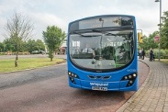
Do you know that from April 1st parking will be free at the city’s seven Park and Ride sites? The seven sites are those at Babraham Road, Madingley Road, Milton, Newmarket Road, Trumpington, Longstanton and St Ives.
The Universal Bus service continues to go from strength to strength and in the coming months will launch a mobile ticketing app. If you would like Universal timetables for your department please get in touch.

Financial assistance is available through the Travel to Work loan for staff who would like to purchase an annual bus ticket.

Carshare
Save money and reduce your carbon emissions by using the Cambridge-wide lift sharing service, Camshare. Lift-sharing even one day a week can make a difference. For sites with a large number of motorists it may be worthwhile to organise a lift-share networking event so staff can meet colleagues who share a similar journey.

Cycling
Cambridge has a proud history of cycling, and with 42% of our staff cycling to work last year we have one of the highest cycling rates in the country.
Eddington Cycling Festival
Eddington Cycling Festival will take place on 28 April at Eddington, North West Cambridge from 10:00-16:00. It will be a fun day for all the family and we would love all University staff to come along. Activities will include a cycle try out (where you can try an exciting range of bikes), a pedal-powered juke box, smoothie bikes, pedal-powered micro cinema and much more!

At a departmental level, we can arrange Dr Bike and cycle maintenance sessions at your department. Please get in touch if you would like to arrange any of these events in your department.
For those who would like to develop their cycling competence, we will hold a number of one-on-one cycle skills sessions across the month. The details of how to apply for these sessions will be available in the next few weeks.

Some other fun events suggestions that can be organised in a department include lunch time team cycles or slow bicycle races. If you need any water bottles for giveaways or bike seat covers, please get in touch.

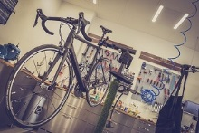
Spotlight on Travel month is a great opportunity to let staff know of all the help that is available to help them to get cycling.
- The Cycle to Work Scheme allows staff to purchase a bike and accessories tax-free.
- The Travel to Work Loan can be used to purchase a bike.
- Staff can avail of discounts in certain shops.
- Cycle repair stations have been installed across the operational estate.

If you would like to distribute fliers for these schemes in your department please contact the Transport team.

Walking
Walking is not only good for our health but it can help us to be more creative during our workday. So how do we encourage our colleagues to be more active? Or, how do we share the stories of our colleagues who thoroughly enjoy their walk to work?

Last year 9% of staff walked to work each day and we would like to raise that figure. Friday 27th of April is “On your feet” day; the initiative encourages staff to get active both in their commute and during their workday. We would love to see just how active staff are - take a photo of your walk to work, share it on social media and tag us to be in with a chance of winning a prize or organise a lunchtime walk with your colleagues to get out, be active and clear your mind.

Train travel
The University of Cambridge is a member of Travel for Cambridgeshire. Through this scheme University staff are entitled to a 10% discount on Great Northern and Greater Anglia routes. This discount is valid on season tickets purchased with validity of one month or above.

Fliers for this scheme are available via the Transport team.

Event or promotion ideas -travelling sustainably at work

Air travel in your department
As mentioned above, the impact of air travel on the University’s carbon footprint is substantial and through Spotlight on Travel month and the Carbon Challenge we hope to provide staff with a number of alternatives to international flights.

You can help by:
- Filling out this survey on travel within your department.
- Organising a demonstration with your colleagues of videoconferencing equipment or videoconferencing software in your department.
3. Providing information on how to use videoconferencing facilities on staff notice boards (UIS should be able to provide guidance if you need it).

Internal (UK only) flights are the most carbon intensive way to travel and we would encourage staff to travel by train where possible.

Utilising pool bikes
There are at present four centrally managed pool bike schemes in the University – Greenwich House, the Maxwell Centre, David Attenborough Building and the Clinical Schools.
These bikes will be made available through MICAD in April and will be available for staff on nearby sites to use.

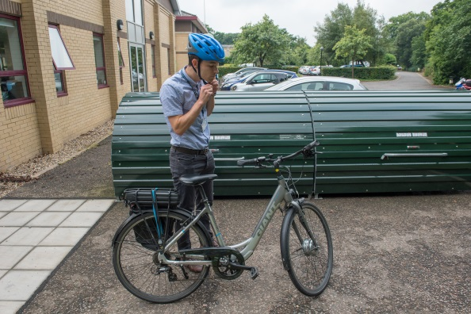
To use the bikes, staff must:
- Sign the user agreement and return the agreement to the reception which manages the bikes that you will use
- Register on MICAD
- Book their bike via MICAD – we advise that staff allow time either side of the booking to collect the bike and to avoid delays
- Return the bike on time. All bikes must be returned to the site where they were collected.

Further information on pool bikes can be found here.

If your department has pool bikes which are not centrally managed, we would like to hear from you so we can include those bikes in our maintenance schedule.

Car clubs
To facilitate staff travel during the workday when staff have commuted by bike or on foot, a number of University departments have set up car club accounts.
Find out if your department has a car club account to access a vehicle during your workday.

Tell us all about your Spotlight on Travel plans

Newsletters
This month we are trialling a new approach when it comes to communication, we intend to deliver information through each department’s newsletter or intranet. We can either send you a template article which you tailor and distribute via your department’s newsletter, or we can send a complete article to your department’s communications team. Either way we would love to hear from you!

Social media
We are happy to share the details of any events or initiatives through Twitter (@cambridgesust), Facebook (@CUenvironment) and Instagram (@cambridgesust). Please do keep in touch throughout the month.

Department for Transport (2014). Claiming the Health Dividend

