Spotlight on Waste Month 2017 –
The 4 Weeks, 4 Rs Challenge!

During Spotlight on Waste Month, November 2017, the University of Cambridge Environment & Energy section are running a ‘4 weeks, 4 Rs’ challenge. In each week of the month we will be breaking down the challenge of waste into 4 simple topics, and challenging you to take them on!

In this document we’ve set out some simple ways you can improve your performance, engage your colleagues and have some fun along the way! Send us your pictures or write-ups detailing activities you take, and any University building, department or College completing one action for each of the 4 Rs will receive a special Environment & Energy prize pack including some Cambridge KeepCups, Fairtrade chocolates and a bottle of wine!

Week 1 (6 Nov – 10 Nov): Record
As the old adage goes “you cannot manage what you can’t measure”. Over the course of the first week, we recommend teams get to grips with the challenge that is ahead of them. This could include:
- Carrying out a simple check of office waste collection infrastructure and procedures. You can refer to the checklist on page 3 of the Waste & Recycling Guidance for this!
- Undertake a waste audit. Guidance on this is available on the E&E website.
- Request data on your building or site’s recycling performance from the Environment & Energy section. Thanks to the University’s new waste contract, it’s now possible to receive weights and proportions of waste by site, on a monthly basis. This data gives a great benchmark for comparing performance over time!
- Conduct a stock inventory. University departments are encouraged by the Safety Office to adopt Chemical Inventories, with a preferred system now available for use. Stock inventories of more common day-to-day items such as stationary can also help to keep track of use and purchases.

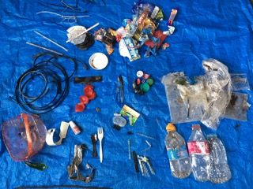
Case study: Picking up the pieces at Philosophy
In Summer 2017, the Faculty of Philosophy walked their site and did a “picking up the pieces” challenge. What they found in just one hour (pictured) was astonishing; single use plastics, old plastic ties, a fruit container and much more, strewn across a small area. All were plastics that will not degrade for hundreds of years. If you would like to ‘pick up the pieces’ with your colleagues over a lunch time, be sure to take appropriate safety precautions (gloves etc!) and once your collection has been completed lay the waste out and share a photo your findings on twitter @CambridgeSust, Facebook @CUenvironment or on Instagram @cambridgesust with the hashtag #SpotlightonWaste. Using the waste you’ve collected to create a message can also be pretty powerful! During Spotlight on Waste month we’ll have prizes for the best photographs (we promise the prize will not be made of plastic!)

Week 2 (13 Nov – 17 Nov): Reduce
Reducing, preventing or minimising waste is a top priority on the waste hierarchy but is often forgotten. Reducing what we consume is the most effective way to avoid creating waste. Activities this week could include:
- Holding a stationary amnesty, asking staff to return unused or unwanted stationary, to ensure that new ones aren’t ordered unnecessarily. This can be as simple as having a well-signposted table or box in a visible area!
- Contact a supplier to your building or department, to see if they operate any ‘take-back’ schemes for used items or packaging. Several University departments have had success in contacting their suppliers to ask about dealing with certain waste streams. This has led to the use of printer cartridge recycling and pipette rack take-back schemes – which are often not well publicised!
- Review purchasing criteria, taking into account sustainable procurement options. Guidance on this is available on the Environment & Energy website.
- Take a plastic-free or paper-free challenge in your department! Can you go for a whole week without using (or disposing of!) one particular material? This can be a great way to raise awareness of the challenges of waste minimisation, but can also help identify alternatives to common disposable items.
Case study: Re-using pipette racks in BioPath
In the BioPath Stores based on the Old Addenbrookes site, staff have worked with one supplier, STARLAB, to set up a collection scheme for used pipette tip boxes. Rather than the boxes being disposed of to recycling bins where they risk not being properly recycled due to contamination or other issues, the BioPath stores collect the STARLAB items, and the supplier make regular collections to ensure that the items are recycled into new items.

Week 3 (20-24 Nov) Reuse:
Before an item is disposed of, it should be used as much as possible to avoid unnecessary disposal! If it is no longer needed in your own building or department, there may be others that could use it. Luckily, there are several ways to encourage reuse, including:
- WarpIt, the University’s free online sharing platform, allows unwanted but usable items to be publicised across the University to see if others might want them. If awareness of WarpIt is low in your department you could request WarpIt posters or business cards from the Environment & Energy section!
- The University’s Equipment Sharing Programme allows scientific and other equipment to be shared between departments and individuals. Items are listed on a University database available to all staff.
- Many Colleges and departments have organised reuse events such as clothes swaps. Clothes manufacturing has been identified as one of the most polluting industries and “fast fashion” also has ramifications for workers’ rights. For the clothes we have that we no longer want, why not give them a second life through a clothes swap? Pick a date, find a venue and ask staff to bring along their clothes in the morning. It may be best to arrange clothes by size, while some Green Impact teams have charged an entrance fee at similar events to fundraise for charity. A chance to get a new garment and to extend the life of an item that would have been disposed of; win, win! Please contact Environment and Energy if you need clothes rails or mirrors.
- Why not be part of a world record repair attempt – all the while learning how to repair your clothes, your alarm clock or your garden tools, rather than throwing them in the bin? Whatever you have to fix, across the city there are people who can help and more importantly they are happy to pass on their skills to you. Cambridge carbon footprint organises a number of repair cafes each month. On November 11th 2017 they will attempt to beat the world record for most items repaired at a repair café. Further details will be available closer to the time; please contact us if you are interesting in participating. (If you or someone you know enjoys fixing electrical items please get in touch as Transition Cambridge needs a few extra hands on the day. Training will be provided at repair cafes that will take place in October).

Case Study: Farewell to the disposable cup at Obs & Gynae Dept!
- Even though they often display the recycling symbol, disposable cups can be difficult to recycle due to their heat protective lining and can only be recycled in a few areas in the UK. A more sustainable and cheaper alternative to these cups in the long term are KeepCups or reusable cups. It is a cheaper option as many catering outlets, including University Catering Centre outlets, offer a discount on each drink to customers using these mugs. The Department of Obstetrics and Gynaecology gently nudged their colleagues towards reusable cups last year when they pinned the number of disposable cups that had been used in the department in the previous weeks to the staff notice board. Seeing the sheer number of cups that could not be recycled caused many staff to shift to a reusable alternative. Is this something that you would like to try in your department?
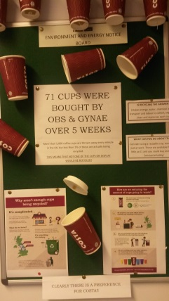
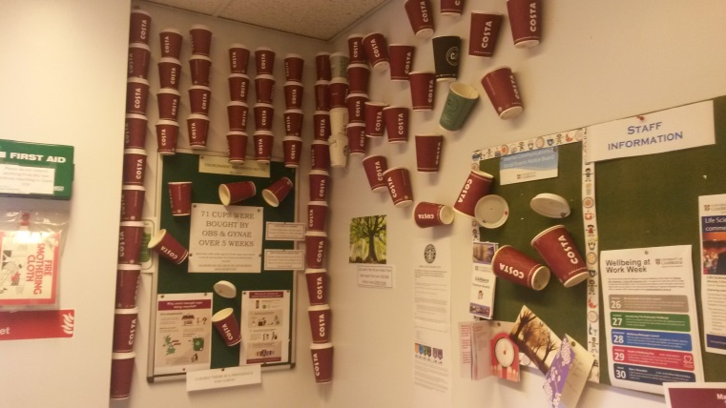

Week 4 (27 Nov – 1 Dec) Recycle:
Throughout this week we encourage teams to raise awareness of what can and can’t be recycled, and what happens to waste when it leaves the University! There’s lots of ways to do this:
- Put up posters and labels on your recycle bins. New pictorial bin labels available on the E&E website have proven to be a popular way to clearly communicate what goes in what bin!
- Hold a simple waste sorting challenge. All you need is some (clean!) different types of waste, and a couple of bins or boxes. A waste sorting game is a good opportunity to chat to your fellow colleagues about how they can recycle better while introducing a bit of fun and competition. You will need three small boxes labelled as follows: general, recycling and food waste and a selection of uncontaminated waste such as paper, Vegware packaging (if it’s used in your building), sweet wrappers, cartons and batteries along with food items like tea bags and fruit. Challenge staff to sort the waste into the correct receptacles in the shortest time possible, with time added on for incorrect sorting! A prize for the quickest time always helps spark some competition…
- Have you ever wondered what happens to the waste put into University bins? What difference does it make to put waste in the wrong bin? During Spotlight on Waste month why not take a tour of your nearest ‘Mechanical Recovery Facility’ (MRF). Contact the Environment & Energy section about visiting Mick George (the University waste contractor)’s MRF, alternatively you can visit the household recycling centre run by Amey Cespa where most domestic waste in the Cambridge area ends up. Email us for details or to reserve your place on the next scheduled visit...

Case Study: ‘Trashy’ TV at Greenwich House?
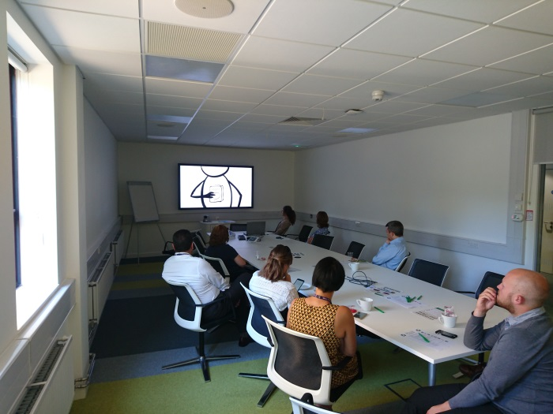
Once out of our sight, we tend not to give waste much thought. Luckily there are a number of informing and entertaining documentaries available which can make us think again. Why not organise a film screening with a question and answer session afterwards to discuss the waste issues in your own department. Staff at Greenwich House held a lunchtime film screening of ‘the Story of Stuff’ (see image to left) as a fun way to get staff thinking about waste issues! Some other films or documentaries (available to borrow from E&E) you could consider are below:

The Story of Stuff - We have a problem with Stuff: we have too much of it, too much of it is toxic and we don’t share it very well. But that’s not the way things have to be, according to the Story of Stuff….
Bag It! - One man’s mission to tackle the plastic in his life
Clean bin movie - A couple challenges each other to live waste free for a year. Who will win?
True cost - An examination of what it takes to produce clothes cheaply
Minimalism: a documentary about important stuff Can we live better with less? See how those who live with less get by
Wasteland - By creating art from the landfills of Rio de Janeiro, the artist Vik Muniz tries to change the lives of those work there…

