Green Impact
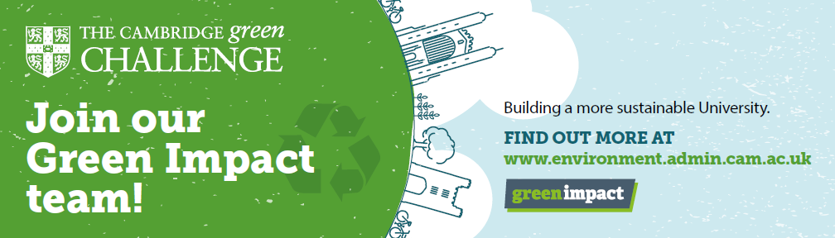
Environment & Energy Coordinator
(only to be used by members of the EEC’s network):
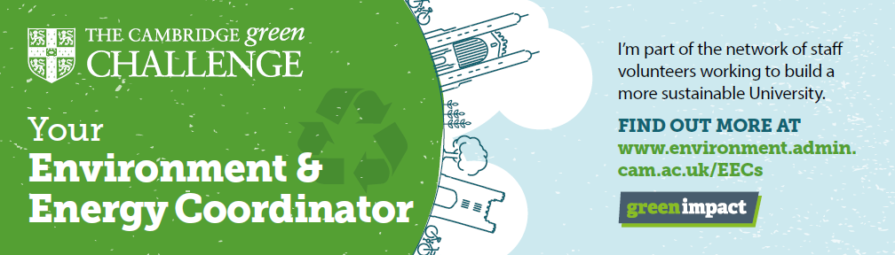
Recycling footer:
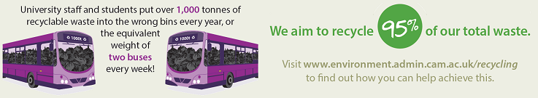
Warpit footer
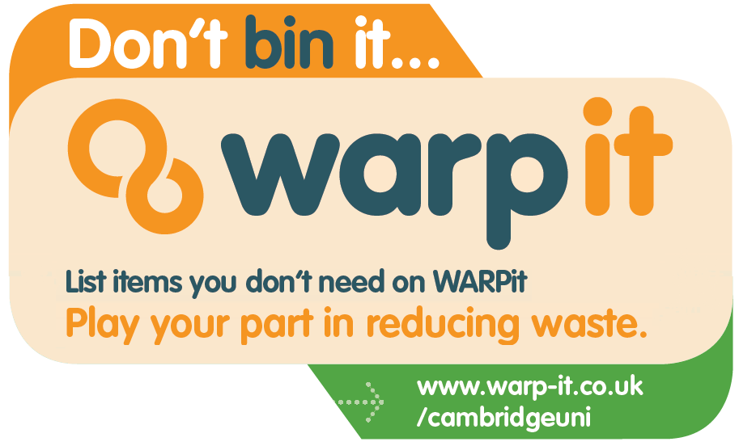

Environmental Sustainability report 2016 footers (pick your favourite one)
Accompanying text:
The University of Cambridge’s first ever Environmental Sustainability Report is now available! Read more at www.environment.admin.cam.ac.uk/Annual-Report
