How to set up a pool bike scheme for staff members at your Institution

Setting up a pool bike scheme for your staff members is an effective way to influence their travel behaviour at work, helping to reduce the level of congestion in Cambridge and carbon emissions generated from traffic. This guide has been put together by the University of Cambridge Environment and Energy Team to provide advice on how to set up a scheme for your Institution.

What is a pool bike scheme?
A pool bike scheme is a bank of bicycles provided for use by their employees in the course of the working day. Pool bikes are kept in a central location and can be booked out by any staff member who is competent at cycling safely on public roads. Pool bikes at the University of Cambridge can be used for cycling between University sites for work purposes and should not be borrowed for commuting purposes.

Why set up a pool bike scheme for your Institution?

- Reduced travel expenses: Save money on taxis and public transport fares
- Increased speed and access: Cycling is often the quickest and most convenient way to travel around Cambridge. Pool bikes allow employees to go from door to door without having to find parking for a car, be stuck in traffic congestion and having to walk to the nearest bus stops
- Demonstrate a positive commitment to sustainable transport: Helping to improve staff morale and attract new staff to your Institution.
- Health and fitness improvements for your staff
- Environmental benefits

Case study: Greenwich Pool Bike Scheme
In January 2016, 300 staff moved from central Cambridge workplaces to the Madingley Rise site and staff had concerns about accessing other University sites throughout the day.

A pool bike scheme has been implemented offering staff the opportunity to borrow electric, folding, hybrid or comfort bikes. In total 16 bikes are available.

A process has been established for booking out the bikes, training staff to use the electric bikes, monitoring the scheme and reporting faults. Cycle training has also been offered to staff. The scheme has been heavily promoted by giving out information packs to all staff when starting work at Greenwich House. Over the first 2 months of the scheme, the bikes were used more than 150 times, with 43 staff members having registered to use the bikes.

Step 1. Identify your requirements
Speak to a selection of your staff to find out whether a pool bike scheme would be an effective way to change your staff members travel behaviour. You may want to find out the following:
- How often staff are required to travel throughout the working day, helping you determine how many bikes you would need to help your staff travel around University sites.
- What types of bikes would be more heavily used by staff, see the information below.
- How far staff are required to travel. If staff are required to travel more than 5 miles, they may be more interested in electric bikes which make cycling easier for longer distances.
- What employees need to take with them. If they are required to carry heavily equipment, supplying panniers may be useful.
- Where will the bikes be stored? The bikes should be stored in a secure location to reduce the risk of theft, such as in a cycle compound.

Types of bikes suitable for a pool bike scheme

This bike is a more comfortable variation of a mountain bike, with wider wheels and bigger treads which provides a smooth, comfortable ride. The handle bars are positioned higher for a more upright ride that is easy on the back. | The folding bike will collapse in seconds into a package that will fit in a car boot or train luggage rack. The smaller wheels will not provide the comfort with road irregularities as easily as larger ones.

The electric bike uses an electric motor to help with propulsion. It’s like a normal bicycle with the addition of a battery pack and an electric motor. This eases the burden of pedalling, making it easier to go uphill or cycle into headwind, and it will help you cycle further, with less effort, than you could on a regular bike. | The hybrid bike incorporates elements of both mountain bikes and road bikes. Hybrids have large narrower tires and smaller tread than comfort bikes meaning it easier for riders to go faster and farther. Frames are lighter than those of comfort bikes, and riding position is more comparable to that of mountain bikes.

Step 2. Determine the costs and funding source. Then…purchase the bikes!
The exact costs of providing a bike pool will depend on the number and type of bikes, and how often they are maintained. The table below provides some indicative costs for equipment. Costs are likely
to vary with supplier, location and bike type.

Item | Cost per bike (excluding VAT)
Hybrid or comfort bike | £200- 300 per bike
Folding bike | £300-£400 per bike
Electric bike (including the battery charger) | £1000-£1200 (depending upon model)
Lights | £50 per bike
Lock (D Lock preferable) | £50 per bike
Panniers. Bikes will need to have a pannier holder on the back of the bike fitted. | £50 for a pair (could be used on one or two bikes)
Quick releases fitted to saddles | £20 per bike
High visibility jackets | £20 per item
High visibility waistcoats | £5 per item
Waterproof trousers | £25 per item
Bike service | £40 per bike
Helmets* | £25-£40
Publicity costs (design of leaflets and posters ) | £150
Cycle Training | £120 for every 4 people for a 2 hour course
* Shared helmets must not be provided for the scheme as this is against University policy. This is because the University cannot guarantee that the helmet has not been damaged by a previous user. Helmets should be offered where keys are given out and collected (for example at reception), for individual staff members to purchase.

What sizes should be purchased?
It is recommended that a mixture of sizes are purchased to cater for all needs and that all bikes are unisex. The bikes should be fitted with ‘quick releases’ on the saddle, to allow the saddle height to be adjusted.

Which bike shops are recommended?
Travel for Cambridgeshire have a list of bike shops in Cambridge which could be asked to quote for bikes, accessories and the maintenance plan, see online at http://www.travelcambs.org.uk/cycle-shop-discounts/

For further information about procurement, contact the Travel Plan Manager.

Step 3. Prepare the Health and Safety documents
Staff members cycling at work are covered by the University’s public liability insurance. The University of Cambridge Insurance Team has provided advice about the safest way to administer the pool bike scheme. The following should be adhered to:
- All pool bike users should be required to fill in a user agreement form before using the pool bikes for the first time, confirming they are a competent cyclist. A copy of this has been included at the back of this document with areas highlighted in grey to be localised for the specific Institution. Any other changes in wording should be agreed with the University’s Travel Plan Manager Travel@admin.cam.ac.uk
- All pool bike users should be offered cycle training before they first use the scheme. They are not required to take part in this if they self-certify they are a competent cyclist
- Shared helmets must not be offered, however the University encourages staff members to wear a helmet. Helmets should be available for sale to pool bike users at the point where keys are given out and collected.

- Staff should be referred to a Cycling at Work Guidance document which should be available online. This sets out how to cycle safely and gives information about helmets and cycle training. A copy of this has been included at the back of this document with areas highlighted in grey to be localised for the specific Institution. Any other changes in wording should be agreed with the University’s Travel Plan Manager Travel@admin.cam.ac.uk

Theft Insurance
The University’s theft insurance does not cover pool bikes and therefore some funding should be allocated for theft of the bikes.

Step 4. Establish the systems for managing the scheme

Nominate a Pool Bike Administrator
- Determine who in the Institution will manage and promote the scheme, they should be the main contact for any problems with the bikes and equipment and should keep a record of the user agreement forms, in case a staff member has an accident.

Determine who will look after and distribute keys, accessories and sell helmets
- Typically, Reception staff are the most suitable staff members to manage this process. They will need to be given training to:
  - Check the booking system daily to determine the number of bookings
  - Log when bikes and accessories have been booked out and returned, to determine if there have been any thefts
  - Report faults and theft to the pool bike administrator to process
  - Charge electric bike batteries
  - Give out accessories
  - Sell helmets to staff
  - Train users how to use the electric bikes (if required).

Set up a booking system
- The booking system could be administered through an excel spreadsheet, a calendar or an online form. This should allow users to pre-book a specific pool bike in advance and allow usage to be monitored.

Step 5. Launching the scheme
Publicising the scheme will encourage staff members to use them who wouldn’t normally cycling at work. It is recommended that a leaflet and poster are prepared. An example from Greenwich House has been included at the back of this document. A launch event could also be prepared to promote the scheme. Setting up a Bicycle User Group is also a positive way to support cycling.

Step 6. Monitor the scheme
Monitor the number of staff registered on the scheme and the usage every week. Monitor the number of complaints and suggestions about the scheme.

Any questions?
If you are interested in setting up a pool bike scheme and would like some more information, please contact Travel@admin.cam.ac.uk to speak to the University’s Travel Plan Manager.

(Template) Pool Bike Scheme User Agreement Form

Please fill in this form if you are planning to use the INSERT NAME OF INSTITUTION Pool Bike. Please read the INSERT NAME OF INSTITUTION Cycling at Work Guidance carefully online at INSERT LINK OF WHERE GUIDANCE IS ONLINE and tick to agree to each statement below.

- I consider that I am competent cyclist. If an accident occurs I will record it and report it to a First Aider to ensure that I have received the treatment required and I will fill in the University of Cambridge accident form online at www.admin.cam.ac.uk/offices/safety.
- If I choose to not wear a helmet when cycling at work, the University of Cambridge will not be held liable for the results of any injury that may have been prevented by the wearing of a helmet. If I choose to wear a helmet that I provide, I understand that the University of Cambridge will not be held liable for the results of any injury that may have been caused by the wearing of my helmet.
- I will adhere to the Highway Code and cycle in a safe way whilst cycling at work.
- I am in good physical health and fit to ride a bicycle. I will not ride a bike if I feel unwell.
- I will perform a routine check on the bicycle to ensure it is in a satisfactory condition before the start of each journey.
- I will lock the bike securely using the locks provided in the correct way, as advised in the Cycling at Work Guidance.
- I will return the bicycle in a good, working order after loaning the bike.
I will report any faults as soon as possible to INSERT EMAIL ADDRESS TO REPORT FAULTS TO
- I will return all equipment (locks, panniers, lights, electric bike batteries) to INSERT LOCATION TO RETURN EQUIPMENT TO after borrowing the bike. If I do not return the bike and equipment, my Line Manager will be informed.

Please note if you do not agree to any of these statements above, you will not be able to use the pool bikes.

If you are interested in free Cycle Training
- Please tick if you would like to receive a free 2 hour cycle training course.

Signed
Print
Date
Please email signed form to INSERT EMAIL ADDRESS TO SEND FORM TO

INSERT NAME OF INSTITUTION Cycling at Work Guidance
- Introduction
The University of Cambridge is committed to reducing the environmental impact of its travel and therefore is encouraging INSERT NAME OF INSTITUTION staff to cycle during the day between sites and for work meetings. Staff members can either use their own bicycle or use the INSERT NAME OF INSTITUTION pool bikes.
This document is a best practice guide for cycling at work and provides information on the pool bikes available, guidance for safer cycling, how to reduce risk of theft and information on the University’s public liability insurance for cyclists.

- The INSERT NAME OF INSTITUTION Pool Bike Scheme
There are INSERT NUMBER OF BIKES AVAILABLE pool bicycles available to borrow. The bikes are easily adjusted to suit various riders of different heights. To choose which size bike is suitable for you, standing astride the frame with both feet flat on the ground and there should be 2-5cm clearance between the top tube and the crotch. The figure below shows the type of bikes available. REMOVE IMAGES BELOW FOR BIKES WHICH ARE NOT BEING OFFERED.

This bike is a more comfortable variation of a mountain bike, with wider wheels and bigger treads which provides a smooth, comfortable ride. The handle bars are positioned higher for a more upright ride that is easy on the back. | The folding bike will collapse in seconds into a package that will fit in a car boot or train luggage rack. The smaller wheels will not provide the comfort with road irregularities as easily as larger ones.

The electric bike uses an electric motor to help with propulsion. Basically, it’s like a normal bicycle with the addition of a battery pack and an electric motor. This eases the burden of pedalling, making it easier to go uphill or cycle into headwind, and it will help you cycle further, with less effort, than you could on a regular bike. | The hybrid bike incorporates elements of both mountain bikes and road bikes to accommodate cyclists who want the best of both worlds in a single bike. Hybrids have large narrower tires and smaller tread than comfort bikes meaning it easier for riders to go faster and farther. Frames are lighter than those of comfort bikes, and riding position is more comparable to that of mountain bikes.

You can borrow lights, high visibility waterproof clothing and panniers. The pool bikes are parked in INSERT WHERE THEY ARE PARKED and labelled with a bike number.

- Booking out a pool bike
- Join the bike scheme by signing the Pool Bike User Agreement which can be accessed by emailing INSERT EMAIL ADDRESS TO GET FORM
- Bikes can then be booked through INSERT LINK TO BOOK OUT BIKES
- The bike comes with a lock, set of lights, and reflectors. You can also borrow high visibility clothing, waterproofs and panniers by adding it into the notes on the booking form.
- To pick up your bike (and any other equipment you have requested), head to INSERT WHERE BIKES ARE COLLECTED FROM and show your card to request the keys to the bike lock.
- If you’re using an electric bike, attach the battery into the panier slot by sliding it horizontally into position. To remove, insert and turn the thinner key and pull the battery out horizontally.

- Reporting faults with the Pool Bikes
Report any faults to INSERT EMAIL ADDRESS OF WHERE TO REPORT FAULTS.

- Pre-cycling checks
Whether you’re borrowing a pool bike or using your own bike for work, the University recommends that before taking the bike out you should check everything is working properly and the bike is adjusted for your comfort.

Please check:
- Mechanical Conditions Are all the parts tight and in good repair?
- Frame Check that the frame fits you
- Tyres Are they fully inflated with plenty of tread and no bald patches?
- Wheels Check spokes are not broken or loose and that both wheels run freely.
- Chain Is the chain oiled and not too loose or too tight?
- Brakes Do both brakes stop the cycle with the minimum amount of pull on the brake levers?
- Brake Levers Are the brake levers positioned so your fingers curve easily around them whilst the palm of their hand is on the grips?
- Saddle Is the saddle straight, roughly horizontal and the correct height for the rider?
- Seat Post Is the saddle the correct height for you with the seat post tight and not over the maximum limit?

- Stay safe whilst cycling

Follow these top tips to stay safe whilst cycling.
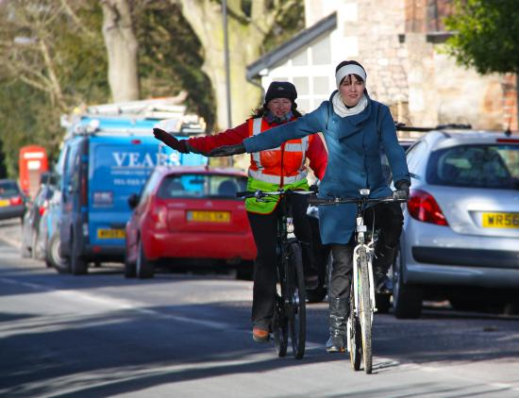
Cycle Training
Whether you’re a confident cyclist or new to cycling, cycle training can help improve your skills and reduce your risk of having an accident whilst cycling. Free cycle training is available for staff delivered by Outspoken Training. The course will take approximately 2 hours. Sign up when you register or email INSERT EMAIL ADDRESS.

Follow the Highway Code

Information on following the Highway Code for cyclists is online here https://www.gov.uk/guidance/the-highway-code/rules-for-cyclists-59-to-82

Helmets
The University encourages staff to wear helmets when using the pool bike scheme. Helmets are available to purchase at INSERT WHERE HELMETS CAN BE PURCHASED. For individual use only. The government guidelines are set out in the Highway Code in Appendix 2, which state that any helmet worn should conform to BS 6863 (SNELL approval) or equivalent.
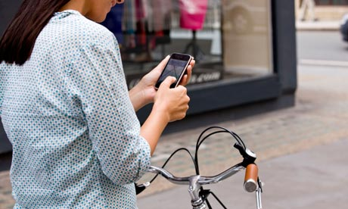

Using Mobile Phones and Handheld Communication Devices whilst cycling at work
It is strongly advised that mobile phones and other handheld communication devices are not used whilst cycling at work. If you need to take a call whilst on the move, stop in a safe place to use your phone.

Be safe Be Seen
It is a legal requirement to have lights and reflectors on your bike while cycling on public roads in the dark.

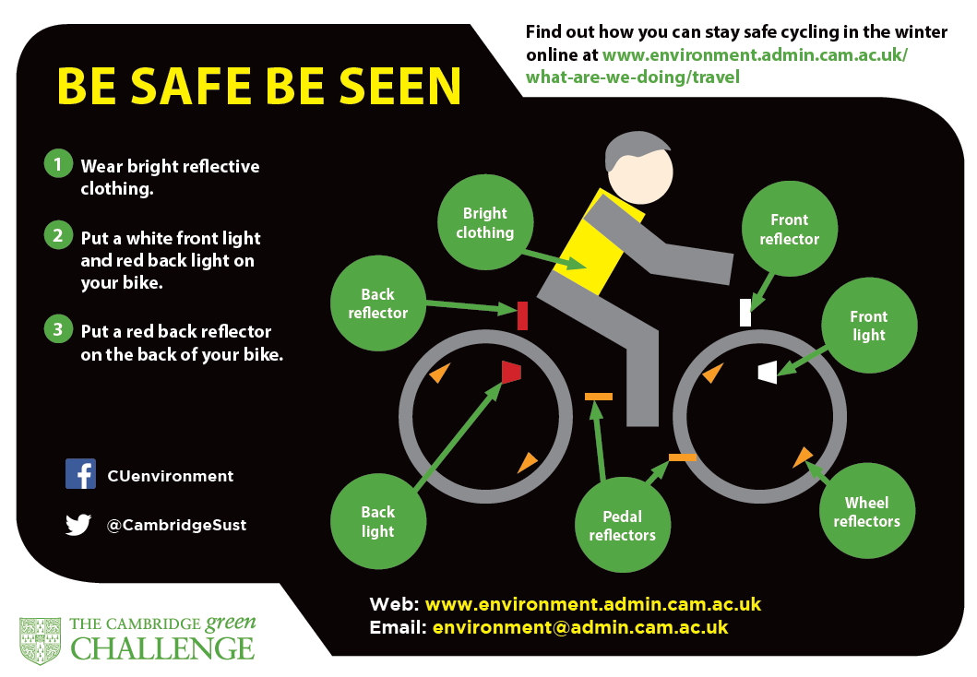

Use quieter, less trafficked routes

Plan your cycle route before you set off by visiting http://www.cyclestreets.net/ You can specify if you want to cycle on a quieter route.

- Reporting a cycling accident

Cyclists are required to report any accident or near miss to their Line Manager as soon as possible, completing a University accident form, which can be found online at: www.admin.cam.ac.uk/offices/safety

Any cycle accidents occurring on the public highway should also be reported to the Police. This information is used by Cambridge County and City Councils to determine key cycle accident hotspots and to allocate funding for future cycle scheme improvements.

- The University’s public liability insurance cover for cyclists
Staff members cycling at work are covered by the University’s public liability insurance.

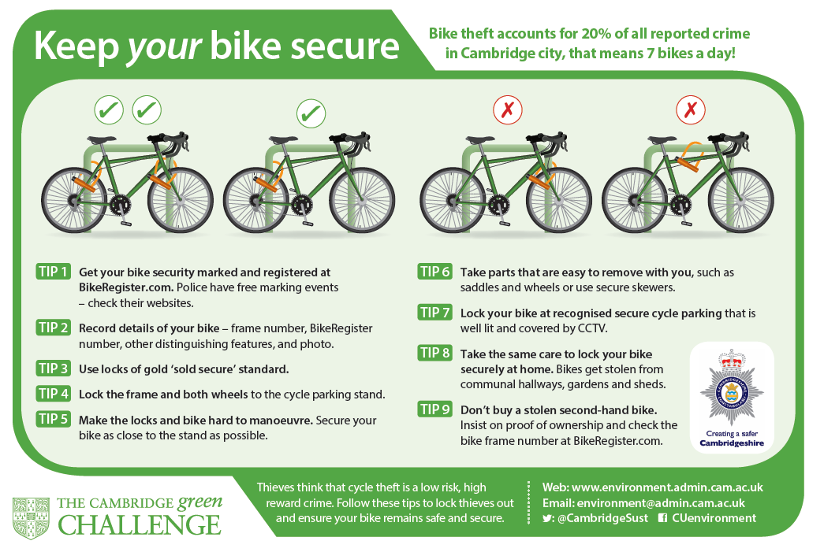
- Reducing the risk of cycle theft

- Reporting a cycle theft
If a Pool Bike is stolen, report this immediately to INSERT EMAIL ADDRESS.

- Find out more
If you have any questions about cycling at work, email INSERT EMAIL ADDRES.

