Green Procurement
Stationery

Environment & Energy Section
University of Cambridge

CONTENTS
GENERAL GUIDELINES 3
Why Should I Bother? 3
How to Use this Guide 3
General Factors to Consider 4
Labels and Certifications 5
BATTERIES 7
BOX FILES AND STORAGE BOXES 7
Box Files 7
Storage Boxes 8
CORRECTION FLUID 8
CORRECTION TAPE 8
DIARIES 9
DOCUMENT WALLETS 9
ENVELOPES 9
ERASERS 10
HIGHLIGHTERS 10
LEVER-ARCH FILES 11
NOTEBOOKS AND NOTEPADS 11
Notebooks: A4 11
Notepads: A4 11
Notebooks: Shorthand 12
PAPER 12
Paper: A4 12
Paper: A3 13
PENCILS 14
Single-Use Pencils 14
Mechanical Pencils 14
PENS 14
Refillable Pens 14
Single-Use Pens 15
PRINTER CARTRIDGES 15
SCISSORS 15

GENERAL GUIDELINES

The University of Cambridge is committed to reducing its environmental impact. Our Environmental Policy promotes ‘a purchasing policy which will give preference, so far as practicable, to those products and services which cause the least harm to the environment.’ Accordingly, this guide provides both general guidance to identify environmentally-friendly stationery products as well as specific examples of such products for commonly used items.

Why Should I Bother?
- Our Environmental Policy: the University has made a commitment to sustainable procurement in its official Environmental Policy. This requires staff to purchase environmentally-friendly products as far as possible.
- Save money: even where eco-friendly products are more expensive to purchase, they can be cheaper over the long-run when factoring in life-cycle costs. For example, non-recyclables will cost significantly more to dispose of due to high landfill taxes.
- Conserve finite resources: if resources are not conserved now there will be major scarcity issues in years to come.
- Protect the environment: many products use substances that degrade the environment and endanger the communities and species that depend on it.
- Purchasing Power: the University has significant purchasing power. Our purchasing practices present a significant opportunity to cultivate a more sustainable supplier culture.
- Set an example: the University also wields a great deal of ‘soft’ power as a world-leading institution. We should and can set an example for others to follow.

How to Use this Guide
Listed Items
For commonly used items, the guide gives examples of specific environmentally-friendly products available on iProc, with *starred items being especially eco-friendly. NB: these lists are not intended to be comprehensive.

To find a listed item, simply insert the catalogue number (Cat No.) into the iProc search function. Alternatively, search for the specific product name given. In many cases, as for pens or envelopes, products listed will be available in several sizes and numbers. It may therefore be preferable to search for the product series name rather than the catalogue number so as to be able to browse through the various options available for the same good.

NB: prices are given as of August 2014 and are liable to change.

Items Not Listed
For items that are not listed, there are more general best practices to consider. Firstly, try including in your iProc search the word ‘eco’ or ‘recycled’. Look for any environmental certification labels (see section below), and take account of the environmental issues noted in the ‘General Factors to Consider’ section.

For any questions or further guidance, contact environment@admin.cam.ac.uk.

General Factors to Consider
Necessity
- Is my existing product refillable?
- Can I find the product from the Cambridge Goods-Transfer Forum? (https://forum.cam.ac.uk/)

Recycling and Reuse
- Can the product sought be reused, refilled, recharged or reconditioned to extend its life?
- Is the product made from recycled material?
- How much of it is post-consumer recycled? (The more the better, because pre-consumer waste is much more commonly recycled.)
- Is the product recyclable?
- Will the supplier take back old items or waste packaging for reuse or recycling?

Other Considerations
- Does the product claim any environmental certifications? (See labels below.)
- Is the product biodegradable?
- Can I avoid excessive packaging, e.g. by buying a larger pack instead of several small packs?
- Is the product locally manufactured and/or locally supplied?

Labels and Certifications

The EU Ecolabel

The EU Ecolabel identifies products and services that have a reduced environmental impact throughout their life cycle, from the extraction of raw material through to production, use and disposal.

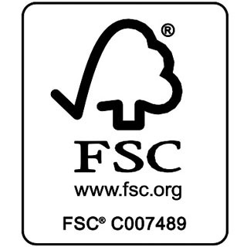
FSC

The Forest Stewardship Council’s “tick tree” logo certifies that a wood product is not contributing to the destruction of the world’s forests.

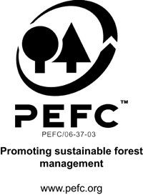
PEFC

Products carrying the PEFC logo are independently certified and can demonstrate their commitment to sustainable development and corporate social responsibility.

The Blue Angel

The German Blue Angel label certifies that a product is environmentally friendlier than others serving the same use. Intended also as a consumer protection label, it also attests to high standards of occupational health and fitness for use.

The Nordic White Swan

The White Swan is awarded to products that reduce the consumer burden on the environment taking into consideration the product’s impact on the environment throughout the product’s lifecycle, from raw material to waste.

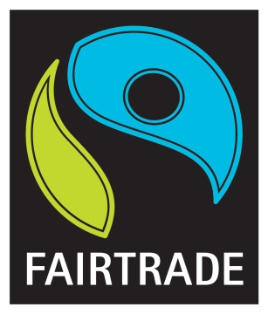
FairTrade

The Fairtrade mark is an independent ethical consumer label that ensures that farmers receive a fair price and workers a fair wage, with an additional premium to invest in community development, including environmental responsibility.

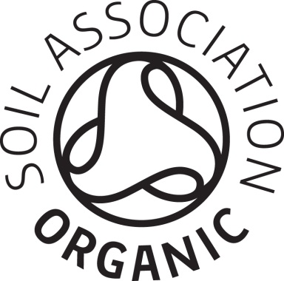
FairTrade

The Soil Association mark is an organic certification that guarantees the produce meets the highest standards of sustainability and quality.

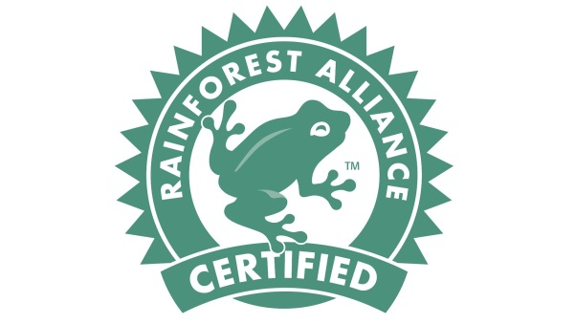
Rainforest Alliance

The Rainforest Alliance seal guarantees that the product in question has met rigorous s standards that conserve biodiversity and provide sustainable livelihoods for their workers.

BATTERIES
Qualities to look for:
- Re-chargeable (even if containing cadmium)
- NiMH (nickel metal hydride) or Lithium rechargeable batteries
- Mercury-free or reduced mercury levels
- Cadmium-free
- Lead-free
- Zinc carbon-free and zinc chloride-free
Product Name/Series | Cat No. | Pack Size | Price
Battery, Ni-Mh +Tags | (various) | (various) | (various)
Battery, Nimh 1300mah Pk4 | (various) | (various) | (various)
Battery, Ni-Mh Aa 2600mah | (various) | (various) | (various)
Battery, Nimh Recyko [Rechargeable] | (various) | (various) | (various)
Battery,Pre-Charged Nimh 2000mah | (various) | (various) | (various)
Duracell Nimh Battery Rechargeable | (various) | (various) | (various)

BOX FILES AND STORAGE BOXES

Qualities to look for:
- Recycled or FSC card
- Recycled plastic

Box Files
Product Name/Series | Cat No. | Pack Size | Price
*Bankers Box by Fellowes Earth [100 mm] | 142433 | 20 | £10.20
*Bankers Box by Fellowes Earth [80 mm] | 142441 | 20 | £9.72
Lyreco Foolscap Box File | (various) | 1 | £0.71

Storage Boxes
Product Name/Series | Cat No. | Pack Size | Price
*Ecoteam Storage Box | 820296 | 10 | £47.15
Niceday Transfer File Eco Brown | 4875867 | 10 | £11.11
R-Kive System Standard Storage Boxes | 538754 | 10 | £34.49

CORRECTION FLUID
Qualities to look for:
- Water-based fluid
- Recycled container
Product Name/Series | Cat No. | Pack Size | Price
Tipp-Ex Ecolutions Correction Fluid 20ml | 139.577 | 10 | £1.40

CORRECTION TAPE
Qualities to look for:
- Recycled content
Product Name/Series | Cat No. | Pack Size | Price
Pentel Retractable Correction Tape | 803200 | 1 | £2.73
Pilot Begreen White Iteline Rt Correct Tape | 3.770.363 | 1 | £1.70
Tipp-Ex Exact Liner Correction Tape | 358578 | 10 | £22.87

DIARIES
Qualities to look for:
- FSC certification
- High percentage of post-consumer recycling
- Processed Chlorine Free (PCF) or Totally Chlorine Free (TCF)

Product Series | Cat No. | Pack Size | Price
*Brownline® EcoLogix 100% Recycled Daily Planner | (various) | (various) | -
Brownline® EcoLogix 100% Recycled Weekly Planner | (various) | (various) | -
Collins Eco 100 Percent Recycled A4 Diary Black | (various) | (various) | -
Collins Eco Diary Pocket Size | (various) | (various) | -
Lyreco Environmental Elements A5 Diary | (various) | (various) | -

DOCUMENT WALLETS
Qualities to look for:
- Recycled plastic
- Recycled or FSC card

Product Name/Series | Cat No. | Pack Size | Price
*Ecoteam Document Wallet Buff | 820121 | 50 | £26.23
Acco Eastlight Slimpick Manilla Wallets | (various) | 50 | £23.16
Elba Full Flap Wallets | (various) | 50 | £9.30
Remarkable Recycled Packaging Document Wallet | (various) | 10 | £18.97

ENVELOPES
Qualities to look for:
- Use re-usable envelopes where possible (particularly for internal mail, where ‘Recycled Internal Envelopes’, often made of recycled paper, provide multiple address boxes that can be written on and can be re-sealed multiple times, cutting down significantly on costs.
- FSC certification
- High percentage of post-consumer recycling
- Processed Chlorine Free (PCF) or Totally Chlorine Free (TCF)

Product Series | Cat No. | Pack Size | Price
*Ecolabel Envelopes | (various) | (various) | -
*EcoTeam Envelope C4 Pocket Recycled | (various) | (various) | -
*EcoTeam Recycled Envelope C5 Pocket | (various) | (various) | -
*EcoTeam Recycled Envelope DL Wallet | (various) | (various) | -
5 Star Envelopes | (various) | (various) | -
Lyreco Envelopes C5 90 G 100 Percent Recycled White | (various) | (various) | -
Lyreco Manilla C4 Peel And Seal Gusset Envelopes | (various) | (various) | -
Office Depot® Brand 100% Recycled Lift & Press™ Window Envelopes, #10 | (various) | (various) | -
Office Depot® Brand Clean Seal™ Catalog Envelopes 30% Recycled | (various) | (various) | -
Office Depot® Brand Lift & Press™ Premium Envelopes, #10 | (various) | (various) | -
Recycled Internal Envelopes C4 324 x 229mm | Viking Number Q23-ND977908 | 250 | £41.49

ERASERS
Qualities to look for:
- PVC free
- Recycled content
Product Name/Series | Cat No. | Pack Size | Price
Staedtler 525 PVC Free Eraser | 4.180.576 | 1 | £0.89

HIGHLIGHTERS
Qualities to look for:
- Water-based ink
- Recycled barrel
Product Name/Series | Cat No. | Pack Size | Price
Ecolabel Highlighter with Water-based Ink Assorted | 268782 | 6 | £3.62
EcoTeam Highlighter Pen Assorted Colours | 301001 | 4 | £0.43
Edding Ecoline 24 Highlighter Assorted Colours | 4.727.519 | 4 | £4.19
Edding Ecoline 24 Highlighter Yellow | 4727474 | 10 | £11.90
Stabilo Green Boss Highlighter Assorted Colours | 5956905 | 4 | £4.13
Stabilo green boss highlighters yellow | 5956869 | 10 | £10.70

LEVER-ARCH FILES
Qualities to look for:
- Recycled cardboard over plastic
Product Name/Series | Cat No. | Pack Size | Price
*Ecoteam Cloud Lever Arch File | (820687) | (unspecified) | £7.93
Esselte No. 1 Power Lever Arch File | 114286 | 1 | £2.09
Leitz 180 Lever Arch File | (337674) | 1 | £1.41

NOTEBOOKS AND NOTEPADS
Qualities to look for:
- FSC certification
- EU Ecolabel
- High percentage of post-consumer recycling (minimum 85%)
- Processed Chlorine Free (PCF) or Totally Chlorine Free (TCF)

Notebooks: A4
Product Name/Series | Cat No. | Pack Size | Price
Clairefontaine Forever A4 70g Recycled Notebook | 4.158.819 | 5 | £6.20
Pukka White A4 Recycled Wirebound Pads (Ruled/Margin) | 2.224.917 | 5 | £3.15
Silvine Notebook Twin Wirebound FSC Paper | 793044 | 5 | £11.16
Silvine Premium Notebook FSC Wirebound Perforated Punched Ruled Margin | 142548 | 5 | £11.18
Silvine Premium Notebook Recycled Wirebound Ruled | 147346 | 5 | £11.18

Notepads: A4
Product Name/Series | Cat No. | Pack Size | Price
* EcoTeam Refill Pad A4 Ruled Recycled | 820199 | 1 | £0.61
*Silvine Refill Pad FSC Paper Feint Headbound Ruled | 793036 | 5 | £6.80
Cambridge A4 Recycled Refill Pad | D15003 | 5 | £7.76
Clairefontaine Forever 17818 Refill Pad Lined A4 | 4.225.229 | 5 | £8.80
Pukka Recycled Refill Pad A4 Headbound | 4.225.309 | 6 | £17.94
Silvine Premium Refill Pad Carbon Neutral Punched Ruled Margin | 153425 | 5 | £7.40

Notebooks: Shorthand
Product Name/Series | Cat No. | Pack Size | Price
Pukka Recycled Shorthand Notebook | 4.225.594 | 3 | £6.96
Oxford npad Shorthand Notebook Recycled Wirebound | 702265 | 10 | £10.40
Silvine Everyday Shorthand Notepad Recycled Wirebound Ruled | 147313 | 12 | £8.15
Silvine Notebook Spiral Bound FSC Paper | 793028 | 10 | £7.25
Silvine Premium Notebook Recycled Wirebound Ruled A5 | 147354 | 5 | £7.95
Cambridge Notebook Recycled Wirebound 70gsm Headbound Ruled | F15002 | 10 | £10.25

PAPER

Qualities to look for:
- FSC certification
- High percentage of post-consumer recycling (minimum 85%)
- Processed Chlorine Free (PCF) or Totally Chlorine Free (TCF)

Paper: A4
Product Name/Series | Cat No. | Pack Size | Price
*Navigator Eco Paper A4 75 Gram White | 2.814.869 | 5 Reams x 500 Sheets | £13.85
Future Multitech A4 75gsm White Paper | 5.362.309 | 5 Reams x 500 Sheets | £64.50
Future Multitech White A4 Paper 80gsm | 978.177 | 5 Reams x 500 Sheets | £13.90
Lyreco White A4 Paper 80gsm | 157.796 | 5 Reams x 500 Sheets | £10.20
Navigator Universal Paper A4 80gsm White | 1.946.072 | 5 Reams x 500 Sheets | £12.30
Office Depot 100% Recycled Printer Paper, Off-White, A4, 80gsm | 522 4743 | 1 Box (unspecified) | £23.10
Office Depot 100% Recycled Printer Paper, White, A4, 80gsm | 5224734 | 1 Box (unspecified) | £12.50
Revive Business Copier Paper Multifunctional Ream Wrapped 80gsm A4 White | 307180 | 500 Sheets | £14.71
Xerox Recycled Pure Plus A4 80GSM | 890243 | 1 Pack (unspecified) | £20.00
Xerox Recycled Supreme A4 80GSM | 4980438 | 1 Box (unspecified) | £32.40

Paper: A3
Product Name/Series | Cat No. | Pack Size | Price
*A3 EcoTeam White Laser Coper Paper 80GSM | 852686 | 500 Sheets | £10.15
*NAVIGATOR ECO PAPER A3 75 GRAM WHITE - REAM OF 500 SHEETS | 4.157.771 | 500 Sheets | £5.24
Future Multitech A3 75gsm White Paper | 5412768 | 500 Sheets | £24.57
Lyreco White A3 Paper 80gsm - Box Of 3 Reams (1500 Sheets Of Paper) | 159.337 | 3 x 500 Sheets | £39.96
Navigator Universal Paper A3 80gsm White | 1.946.083 | 500 Sheets | £6.06
Office Depot 100% Recycled A3, 80gsm | 5226489 | 5 x 500 Sheets | £26.50
Revive Business Paper Multifunctional Recycled Ream Wrapped 80gsm A3 White | 377619 | 500 Sheets | £26.54
Xerox Recycled Pure Plus A3 80GSM | 890251 | 1 Pack (unspecified) | £41.00
Xerox Recycled Supreme A3 80GSM | 890219 | 1 Pack (unspecified) | £41.56

PENCILS
Qualities to look for:
- If you can be confident that staff will reuse them, refillable mechanical pencils are normally preferable to wooden single-use pencils.
- Recycled barrel
- FSC certification for wooden pencils

Single-Use Pencils
Product Name/Series | Cat No. | Pack Size | Price
Staedtler Noris Eco HB Pencil | 2040469 | 12 | £7.20
Staedtler Noris Eco HB Eraser Tip Pencil | 2040476 | 12 | £7.00
Stabilo Graphite Fsc Pencils Eraser Tipped | 4.159.709 | 12 | £7.20

Mechanical Pencils
Product Name/Series | Cat No. | Pack Size | Price
Bic Matic Ecolution Mechanical Pencil | 4561879 | 50 | £11.74
Pilot Begreen Rexgrip Mec Pencil | 3046895 | 1 | £0.89

PENS
Qualities to look for:
- Recycled barrel
- Refillable rather than single-use

Refillable Pens
Product Name/Series | Cat No. | Pack Size | Price
Pilot Begreen Ball Roller Pen | (3336272) | 10 | £22.40
Zebra Eco Jimnie Recycled Retractable Ballpoint Pens | (102402) | 12 | £9.94

Single-Use Pens
Product Name/Series | Cat No. | Pack Size | Price
Bic Ballpoint Ecolution Stick Pens | (5387472) | 60 | £17.50
Bic Ecolutions Stic Ball Pen Recycled | (893239) | 60 | £10.40
Pentel Sign Pen S520 Fibre Tipped | (01659X) | 12 | £10.20
Pilot Begreen B2P Rollerball Pen Recycled | 143672 | 10 | £14.28
Remarkable Biodegradable Cob Frosted Pen | 103336 | 10 | £3.79
Remarkable Recycled Packaging Eclipse Pen | (103316 ) | 10 | £2.85
Remarkable Recycled Packaging Eco Ciak Pen Blue | 103318 | 10 | £2.68

PRINTER CARTRIDGES
Qualities to look for:
- *Remanufactured cartridges
- Recycled plastic
- Vegetable- or soy-based ink
- Recycled packaging
Recommended producers include:
- HP
- Epson

SCISSORS
Qualities to look for:
- Recycled handle
Product Name/Series | Cat No. | Pack Size | Price
Maped Expert 21cm Scissors | 5.393.636 | 1 | £8.39
Maped Expert 21cm Scissors | 5.393.625 | 1 | £7.19
OfficeTeam Essentials Scissors 140 mm | 814369 | 1 | £3.98

